**1) Difference between Open source and Free Source?**

**Free Software:**  
“Free software” means software that respects users’ freedom and community. Roughly, it means that the users have the freedom to run, copy, distribute, study, change and improve the software.

The term “free software” is sometimes misunderstood—it has nothing to do with price. It is about freedom.

**Open Source Software :**  
Open Source Software is something which you can modify as per your needs, share with others without any licensing violation burden. When we say Open Source, source code of software is available publicly with Open Source licenses like GNU (GPL) which allows you to edit source code and distribute it. Read these licenses and you will realize that these licenses are created to help us.

**Difference between Free Software and Open Source Software:**

| **No** | **Free source** | **Open source** |
| --- | --- | --- |
| 1. | Software is an important part of people’s lives. | Software is just software. There are no ethics associated directly to it. |
| 2. | Software freedom translates to social freedom. | Ethics are to be associated to the people not to the software. |
| 3. | Freedom is a value that is more important than any economical advantage. | Freedom is not an absolute concept. Freedom should be allowed, not imposed. |
| 4. | Examples: The Free Software Directory maintains a large database of free-software packages. Some of the best-known examples include the Linux kernel, the BSD and Linux operating systems, the GNU Compiler Collection and C library; the MySQL relational database; the Apache web server; and the Sendmail mail transport agent. | Examples: Prime examples of open-source products are the Apache HTTP Server, the e-commerce platform osCommerce, internet browsers Mozilla Firefox and Chromium (the project where the vast majority of development of the freeware Google Chrome is done) and the full office suite LibreOffice. |

URL OF THE BELOW BLOG:

https://gurujikagyan2.blogspot.com/2022/02/blog.html

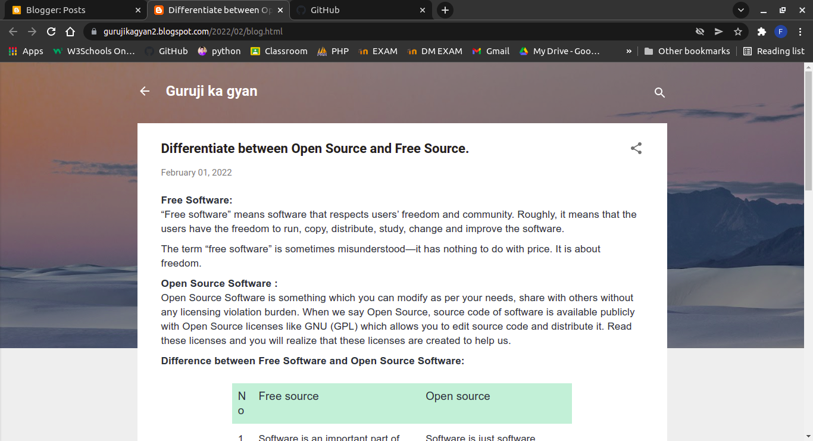

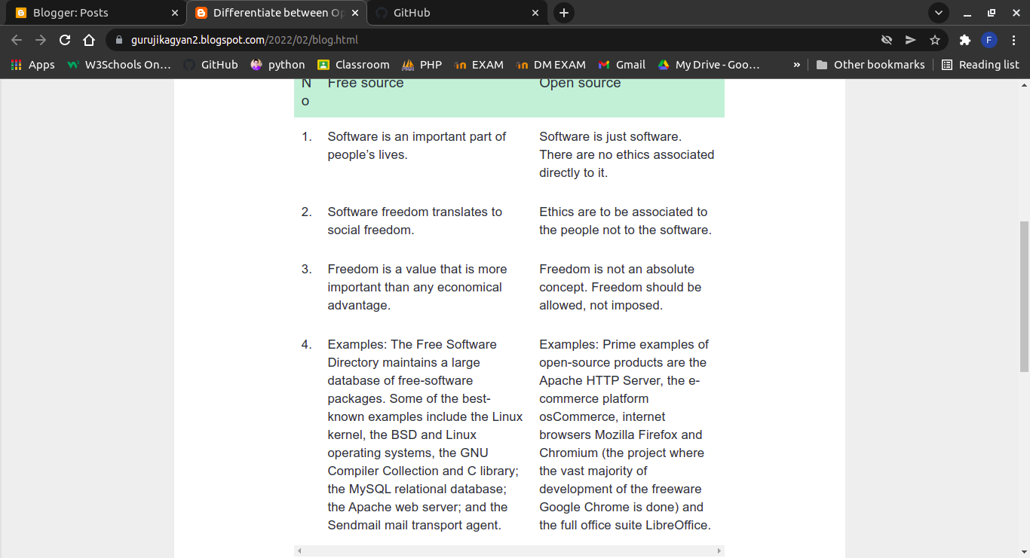

**2) Explain the significance of Green Computing.**

"**Going Green**" is a rising trend establishing itself as the preferred way of doing things while saving the environment. This now appears in a large number of aspects in our lives, such as recycling, energy-efficient devices, clean energy sources, eco-friendly vehicles, green buildings.

Computing has also established its share to contribute to saving the environment under the concept "Green Computing". Green computing is the environmentally responsible and eco-friendly use of computers and their resources. In broader terms, it is also defined as the study of designing, engineering, manufacturing, using and disposing of computing devices in a way that reduces their environmental impact. Green Computing, also known as Green Technology or Green IT, has quickly emerged as the most effective means of utilising technology.

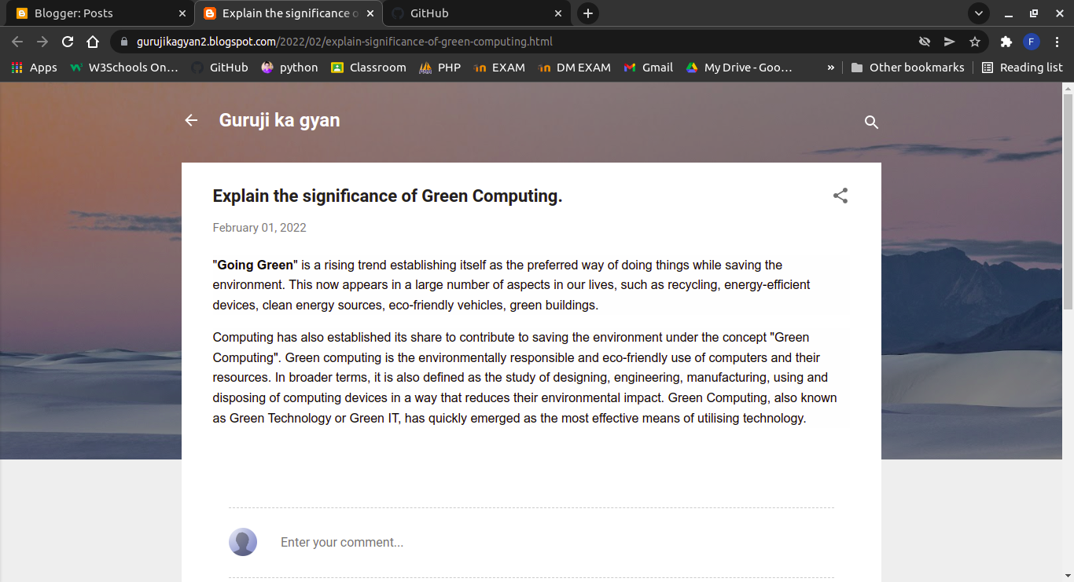

URL OF THE ABOVE BLOG:

https://gurujikagyan2.blogspot.com/2022/02/explain-significance-of-green-computing.html

**3) What is GitHub? Explain the advantages of using Github. Give steps of creating and cloning repository on Github.**

**GITHUB:**

1. GitHub is a code hosting platform for collaboration and version control.

2. GitHub lets you (and others) work together on projects.

**ADVANTAGES:**

**1. It makes it easy to contribute to your open source projects**  
To be honest, nearly every open-source project uses GitHub to manage their project. Using GitHub is free if your project is open source and includes a wiki and issue tracker that makes it easy to include more in-depth documentation and get feedback about your project.

**2. Documentation**  
By using GitHub, you make it easier to get excellent documentation. Their help section and guides have articles for nearly any topic related to git that you can think of.

**3. Track changes in your code across versions**  
When multiple people collaborate on a project, it’s hard to keep track revisions—who changed what, when, and where those files are stored. GitHub takes care of this problem by keeping track of all the changes that have been pushed to the repository. Much like using Microsoft Word or Google Drive, you can have a version history of your code so that previous versions are not lost with every iteration.

**CREATING A REPOSITORY:**

1. In the upper-right corner of any page, use the drop-down menu, and select New repository.
2. Type a short, memorable name for your repository. ...
3. Optionally, add a description of your repository. ...
4. Choose a repository visibility. ...
5. Select Initialize this repository with a README.
6. Click Create repository.

**CLONING REPOSITORY:**

Clone a repository using the command line

You can use Sourcetree, Git from the command line, or any client you like to clone your Git repository. These instructions show you how to clone your repository using Git from the terminal.

1. From the repository, click + in the global sidebar and select Clone this repository under Get to work.
2. Copy the clone command (either the SSH format or the HTTPS).  
   If you are using the SSH protocol, ensure your public key is in Bitbucket and loaded on the local system to which you are cloning.
3. From a terminal window, change to the local directory where you want to clone your repository.
4. Paste the command you copied from Bitbucket.

URL OF THE BELOW BLOG :

https://gurujikagyan2.blogspot.com/2022/02/what-is-github-explain-advantages-of.html

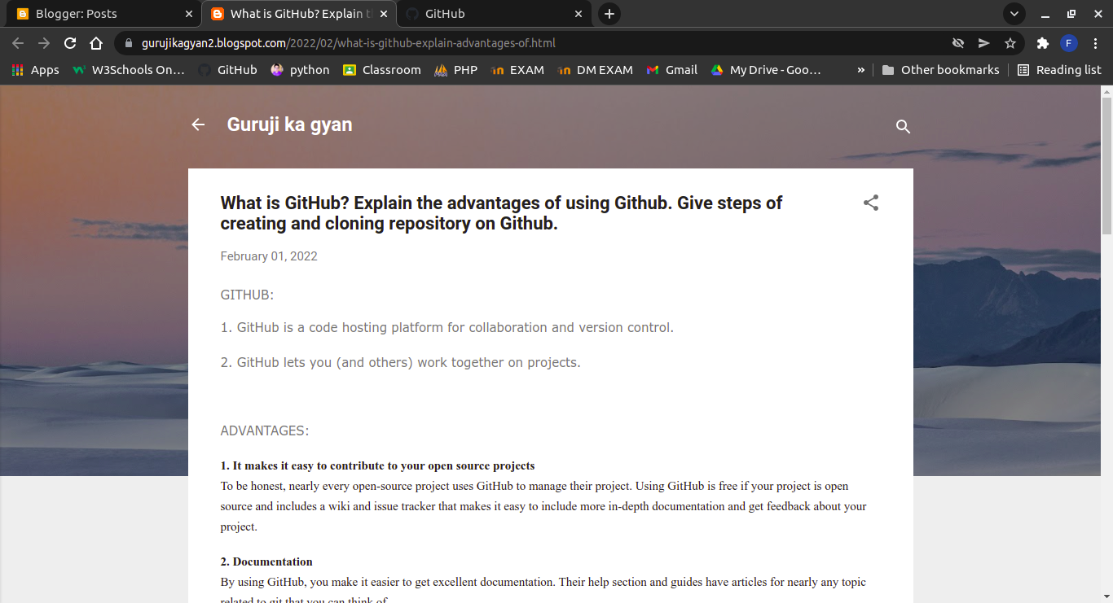

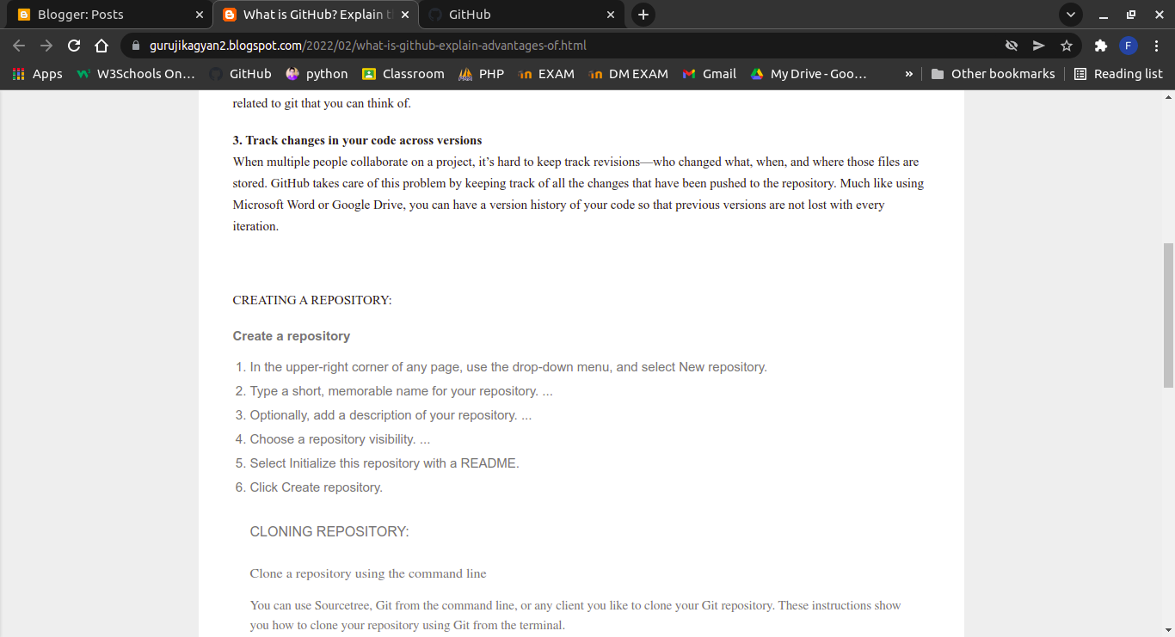

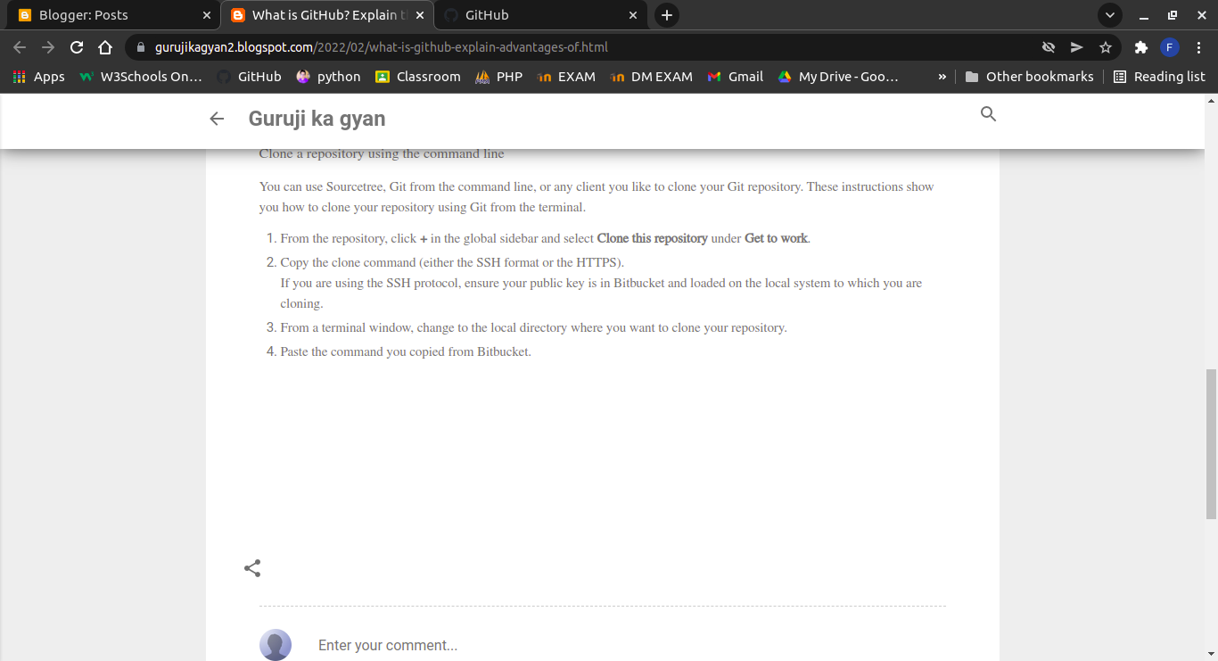

**4) Differentiate between Tools and Technologies.**

**What is a Tool? Analytical Overview**

Basically, a tool can be anything digital or manual as well. For example, when a professional essay writer uses applications such as referencing generator and word count tools to perfect the paper, then the resources used are termed as “tools”.

It means, you are leveraging the potential of certain platforms, resources and database to add perfection to a particular task. Whenever you would venture out to achieve something, you would require a couple of supportive elements to back your endeavors. That’s exactly where “tools” come into play.

**What is Technology? Critical Evaluation**

Technology is basically the discipline that deals with the art and science of applying scientific insights to enhance and streamline the process of manufacturing and producing a particular item. Also, technologies are harnessed to achieve certain long-term goals within a particular organization.

To explain further, technology is basically a branch of knowledge that deals with the application of scientific knowledge to automate certain complex processes. In addition, if you aim to explore the practical purposes of certain applications or enhance their performance for the better, you need technology to jump to the next level.

URL OF THE BELOW BLOG:

https://gurujikagyan2.blogspot.com/2022/02/differentiate-between-tools-and.html

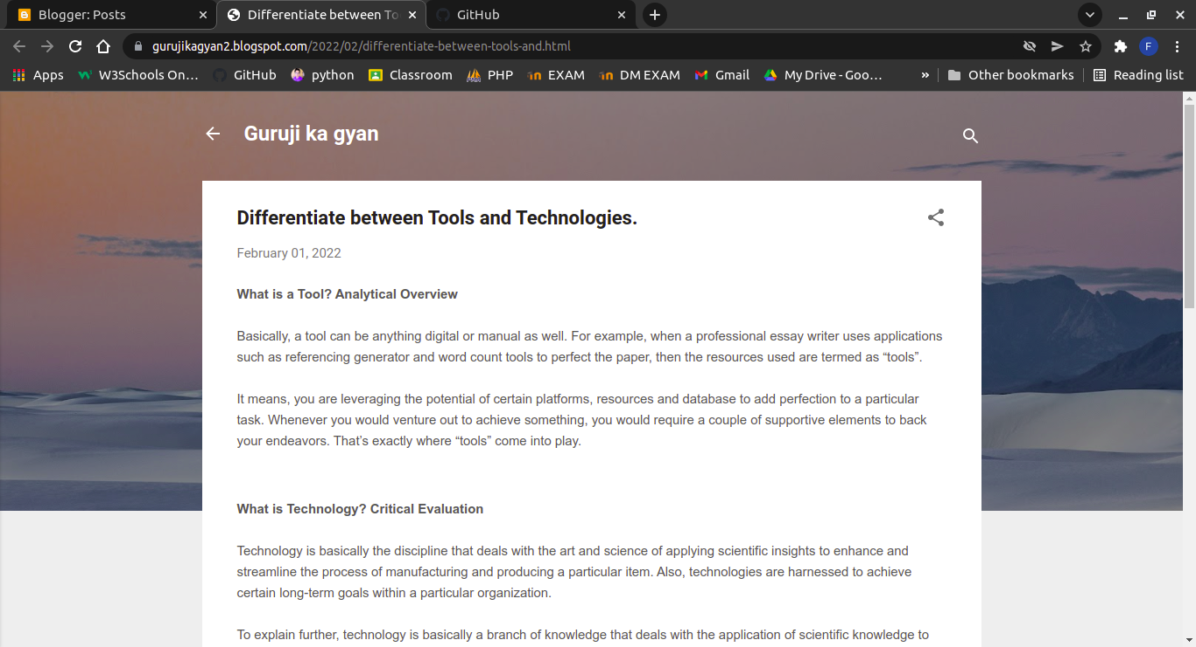

**5) Explain the feature and working of any of tool used in Online Teaching and Learning Process.**

### **Here i am taking GOOGLE MEET for Online learning and teaching.**

#### **What is google meet?**

Google Meet is a video-communication service developed by Google. It is one of two apps that constitute the replacement for Google Hangouts, the other being Google Chat.

#### **FEATURES:**

1) Unlimited number of meetings.

2) Live captioning during meetings.

3) Compatible across devices.

4) Video and audio preview screen.

5) Adjustable layouts and screen settings.

6) Controls for meeting hosts.

7) Screen sharing with participants.

8) Messaging with participants, and many more!

#### **WORKING:**

On both the Meet mobile app and on a computer, simply **pull up Google Meet and click or tap "Use a meeting code"** (it may say "Enter a meeting code" on mobile). Once your code is in, provided the session has started, you'll enter the call and can begin talking with your team.

**FOR EDUCATION:**

Educators can create a unique Meet link for each class, which is displayed on the Classroom Stream and Classwork pages. The link acts as a dedicated meeting space for each class, making it easy for both teachers and students to join.

The Meet links created by the Classroom integration are nicknamed meetings. For education users, participants can’t rejoin nicknamed meetings once the final participant has left, unless they have meeting creation privileges to start a new meeting. This means if the instructor is the last person to leave a nicknamed meeting, students can’t join again until an instructor restarts the nicknamed meeting.

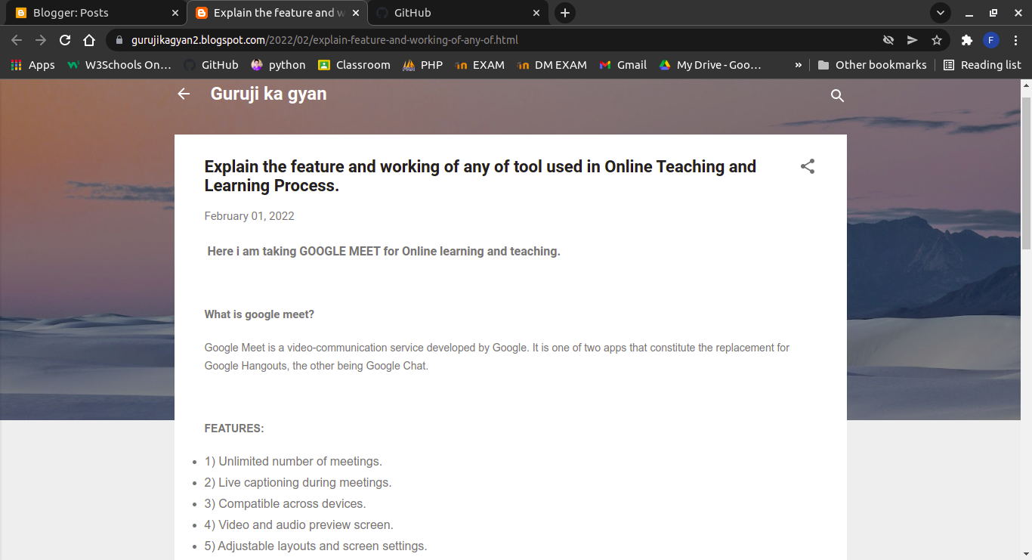

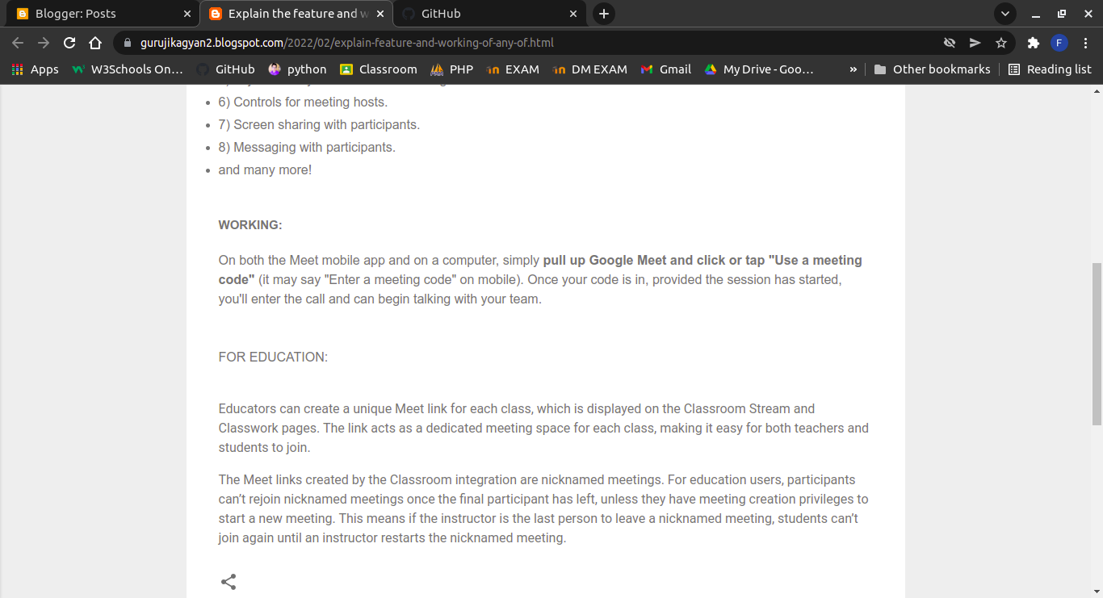URL OF THE ABOVE BLOG:

<https://gurujikagyan2.blogspot.com/2022/02/explain-feature-and-working-of-any-of.html>